

Luleå University of Technology, Department of Computer Science, Electrical and Space Engineering

Assignment 2

Data Visualization (D7055E)

GROUP NO. 13 members:
Madelene Gustafsson
Carlos González Mendoza
Fatima Juairiah
Michelle Lima Ruda
Talha Imran

Date: November 30, 2025

1. Contributions
At the beginning of the assignment, each group member worked individually on the coding tasks. This allowed everyone to explore the data, test different visualization approaches, and learn at our own pace. Once we felt confident with our separate attempts, we scheduled a Zoom meeting, similar to our process in Assignment (1). During this meeting, we reviewed each member’s code and visualizations, discussed the reasoning behind our choices, and agreed on how to combine the best parts into a solution for Assignment (2).
After finalizing the coding and visualizations together, we used the same report structure as in Assignment (1) but adapted it to match the requirements of the current task. The writing process was divided evenly across the group so that each member contributed at least one section of the report. Finally, we all read through the entire document to ensure clarity and that everyone felt satisfied with the final outcome.

2. Data Preparation and Cleaning
The obesity dataset was first imported and reduced to only the variables needed for the task, the state names and their corresponding obesity percentages. The state name column was then renamed to ensure consistency with the attribute naming in the U.S. state shapefile.
The shapefile was loaded and prepared by assigning and converting its coordinate reference system to a standard geographic CRS suitable for mapping. Minor geometry issues were resolved by filtering out invalid shapes and applying a buffer fix to clean the polygons.
After preparation, the cleaned obesity data was merged with the shapefile using the state name as the matching key. Any rows without valid geometry were removed to avoid issues during visualization. Once merged, the dataset contained all necessary spatial and numerical attributes, properly aligned for plotting the obesity distribution across U.S. states.
For Q2, the dataset was first cleaned by removing cities with missing elevation data to ensure completeness. Cities from Hawaii, Alaska, and Puerto Rico were excluded, retaining only those in the contiguous United States. All geometries were projected to the EPSG:3857 coordinate reference system to allow accurate spatial calculations. Empty or invalid geometries were removed to ensure data integrity. Next, all state polygons were merged into a single continental U.S. shape, and only cities located within this polygon were retained. The final dataset consists of valid, projected city points within the contiguous United States, ready for spatial analysis and mapping.
The public schools dataset was first loaded as a GeoDataFrame. Since the analysis focused only on elementary and high schools, we filtered the data to keep records where the LEVEL_ attribute matched these categories. The cleaned subset was then grouped by state and school level to calculate the number of schools in each category.
The grouped results were reshaped into a pivot table to compare elementary and high school counts side-by-side. This prepared, structured dataset was then ready to be visualized in a grouped bar chart.
For Q6, the dataset was loaded from the geodatasets API, which already provides clean spatial data with valid geometries and a suitable coordinate reference system. After importing the data, we reviewed its attributes and focused on only the variables required for the three visualizations (like HR60, HR90, PO60, PO90, and RD90).
Only light data preparation was necessary. Instead of removing columns or restructuring the table, we worked directly within the original GeoDataFrame and created new derived variables to support the visualizations, for example, calculating population change (PO90-PO60) and homicide rate change (HR90-HR60). These transformations enabled the detection of meaningful spatial patterns without requiring additional cleaning steps.
The preparation mainly involved reviewing the variables, computing a few new indicators, and ensuring the data was in a suitable form for mapping and narrative visualization.

3. Visualizations and Observations/Insights
Q1.
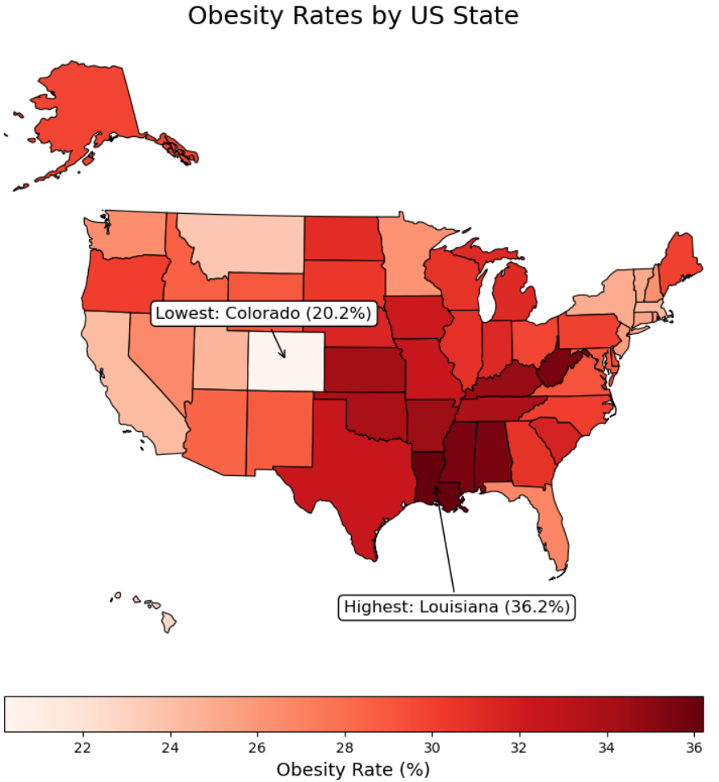
The map shows the distribution of adult obesity rates across the United States. Each state is represented with a shade of red, where darker tones indicate higher levels of obesity and lighter tones represent lower levels. This color-based representation makes it easy to visually compare obesity levels across the country at a glance.
One observation is the clear regional pattern. The highest obesity rates are concentrated in the Southern states. Louisiana stands out as the state with the highest recorded value, reaching over 36%. Several neighboring states, like Mississippi, Alabama, and Arkansas, also show very dark shades, indicating similarly high levels. This suggests that obesity in the U.S. is not evenly distributed, but could rather be influenced by regional factors like lifestyle, socioeconomic conditions, food access, or cultural habits.
In contrast, states in the Western region show noticeably lower obesity rates. Colorado is highlighted as the state with the lowest rate, around 20%. Other nearby states, like Utah and California, also appear relatively light on the map. This also strengthens the pattern that certain regions consistently perform better in terms of public health and weight-related outcomes.
In the visualization, only the names of the states with the highest and lowest obesity rates are explicitly labeled which was intentional. Adding labels for all fifty states would have potentially resulted in a cluttered map, making it harder to focus on the main purpose of the task, highlighting the extreme values. Too many overlapping labels would draw attention away from the central insight and potentially overwhelm the viewer, especially since the shapes of the states are already well-known and easily recognizable.
The map’s goal is to communicate the overall distribution of obesity across the U.S. while emphasizing the two most significant data points. By limiting the annotations to Louisiana (highest) and Colorado (lowest), the visual can remain clean and more readable. Viewers who wish to compare additional states can do so visually through the color scale, which is sufficient to understand regional patterns without needing every state name displayed.
Q2.
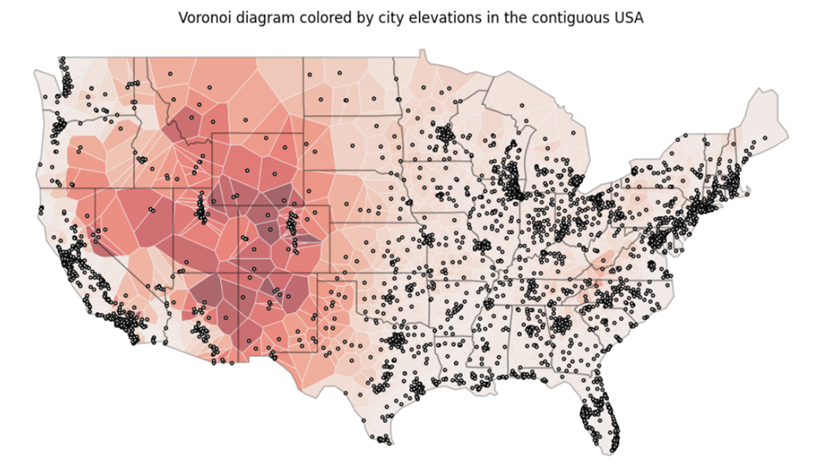

This Voronoi diagram illustrates how elevation varies across cities in the contiguous United States. The U.S. boundary and city locations are first projected into a common coordinate system, and only cities within the national boundary are retained. A Voronoi diagram is then generated from these points, dividing the country into regions where each location is closest to a specific city. These regions are restricted to the U.S. outline to ensure proper alignment with the map.
To assign elevation, the centroid of each Voronoi polygon is matched to its nearest city using a spatial search structure, and the polygon inherits that city’s elevation. The polygons are colored by elevation, producing a gradient that highlights geographic patterns: darker shades reflect higher elevations, especially in the Rocky Mountain states, while lighter shades represent lower elevations typical of the East Coast, Southeast, and other low-lying regions. City point markers and the national boundary are overlaid to provide geographic context.
Because cities are unevenly distributed, the Voronoi regions vary greatly in size. In the West, where cities are more widely spaced, the regions are large; in contrast, densely populated areas such as the Northeast and California generate many smaller, tightly clustered regions. The resulting visualization emphasizes the major high-elevation zones of the Rockies and High Plains and contrasts them with the lighter-colored, low-elevation areas of the coasts and Midwest.
The goal of this Voronoi diagram visualization is to show how elevation varies geographically in relation to U.S. cities, while also illustrating how geographic space is divided based on proximity to each city. It visualizes elevation patterns, connects cities to their surrounding areas to provide insight into spatial influence and coverage, and demonstrates how densely or sparsely cities are distributed. The visualization also provides geographic context for city locations, combining elevation, city positions, and geographic space into a single intuitive map that communicates both topography and spatial distribution.

Q3. 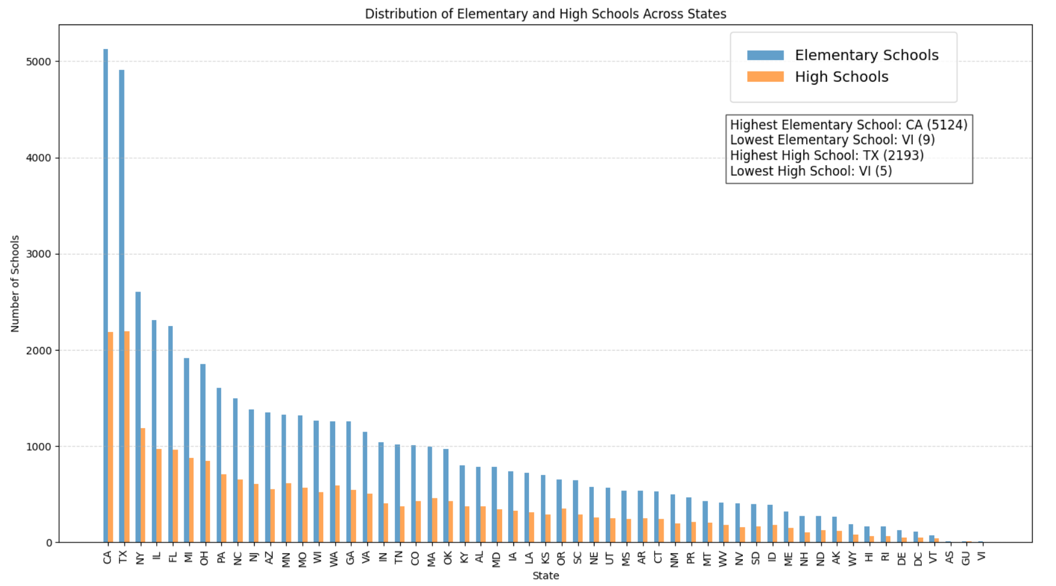
This visualization presents a comparative distribution of Elementary Schools and High Schools across different U.S. states. The grouped bar chart enables a side-by-side comparison, making it easier to observe which states have the highest and lowest counts for each school level. The chart is sorted in descending order based on the number of elementary schools, which helps highlight the states with the largest education infrastructures.
To generate the plot, the data was grouped by state and pivoted to extract the total counts of schools by level. The bars were plotted with equal width and offset so that each state contains two bars—one representing elementary schools and the other representing high schools.
- States with the Highest Number of Schools:
California (CA) has the highest count of elementary schools, which indicates a very large primary-level education system. Texas (TX) comes in second in case of elementary schools. For the High school level it is showing a very similar and closely comparable count with California (CA).
- States with the Lowest Number of Schools:
The territory Virgin Islands (VI) has the lowest number in both categories, elementary schools and high schools. This result is expected given its small population size.
Larger states such as CA, TX, NY, FL, and IL dominate the upper end of the distribution. In contrast, states with smaller populations like WY, VT, DE, SD cluster near the bottom. Highly populated states maintain substantially more schools at both levels, while small states and territories operate far fewer. For almost all states, the number of elementary schools is significantly higher than the number of high schools. This aligns with typical educational structures, where elementary schools are more numerous. The visualization provides an intuitive understanding of national education distribution patterns.
Q4.
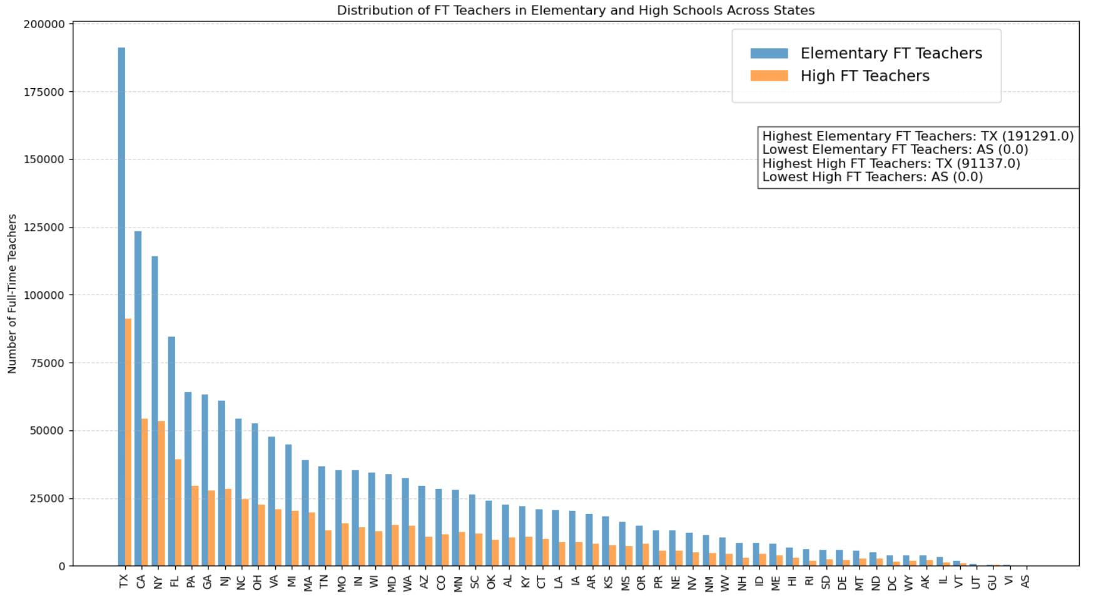
The visualization shows the number of full-time teachers (FT_TEACHER) in Elementary and High schools across U.S. states, sorted from highest to lowest based on Elementary school teacher counts. The distribution reveals strong variation among states in terms of teacher staffing levels.

States with the Highest Number of Full Time Teachers
- Elementary Schools : Texas (TX) has the highest number of full-time elementary teachers, significantly exceeding all other states. Following Texas, California (CA) and New York (NY) also show very high teacher counts.
- High Schools : Texas (TX) again leads with the highest number of full-time high school teachers. California (CA) and Florida (FL) follow as the next largest contributors.

States with the Lowest Number of Full Time Teachers
- Elementary Schools: AS (American Samoa), VI (Virgin Islands), GU (Guam) have the lowest counts of full-time elementary teachers.
- High Schools : Similar states—AS (American Samoa), VI (Virgin Islands), GU (Guam) also appear at the bottom for high school full-time teachers.
The teacher distribution mirrors population size and school density: large states such as TX, CA, NY dominate both categories. The gap between elementary and high school FT teachers is consistent, with elementary schools always having more teachers than high schools. Smaller or less populated states show much lower staffing levels, clustering at the right side of the graph.
Q5.
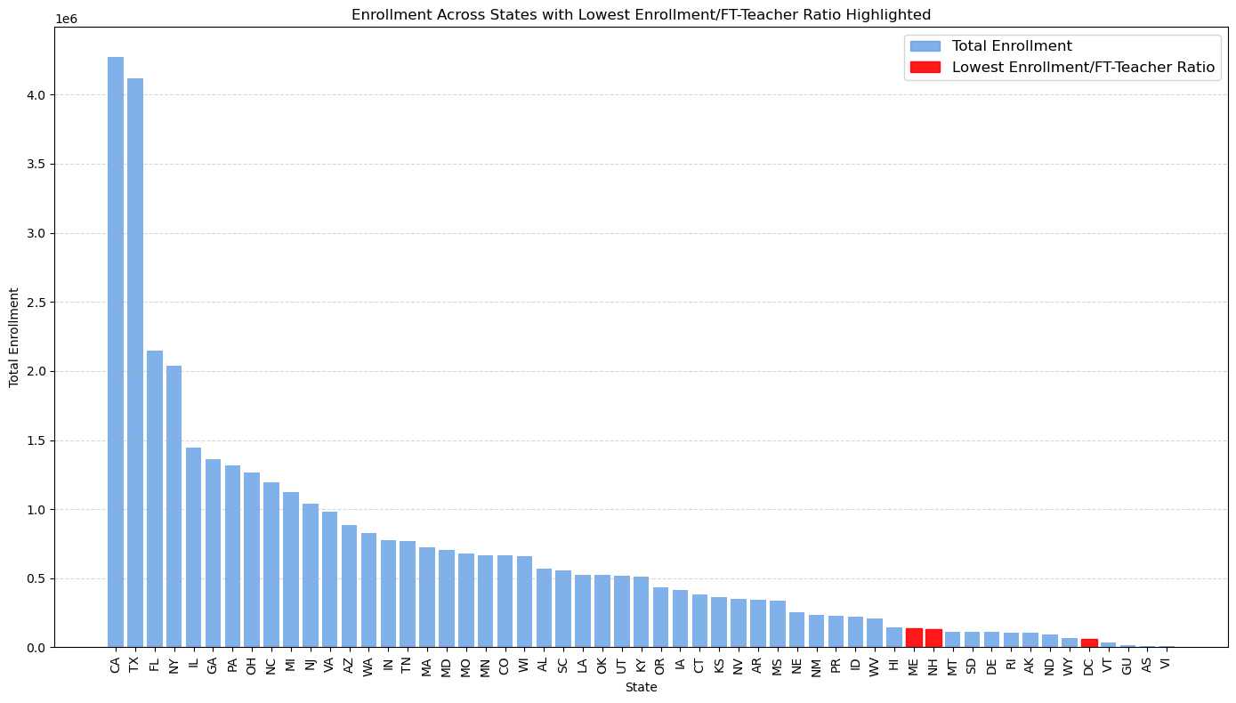
The visualization illustrates the total student enrollment across U.S. states and territories, sorted from highest to lowest. Each bar represents the cumulative enrollment within a state, allowing a clear comparison of student population sizes nationwide. A key feature of this graph is the highlighting of the three regions with the lowest Enrollment-to–Full-Time Teacher (FT_TEACHER) ratio—these bars appear in red, making them visibly distinct from the rest.

Overall Enrollment Distribution
States with the largest populations naturally dominate the upper end of the enrollment spectrum:
- California (CA) leads with the highest total student enrollment.
- Texas (TX) and Florida (FL) follow, consistent with their large populations and extensive school networks.
- States such as New York (NY), Illinois (IL), and Georgia (GA) also show significantly high enrollment figures.
On the opposite end, smaller states and U.S. territories display much lower total enrollments:
- Wyoming (WY)
- Vermont (VT)
- Washington D.C. (DC)
- Territories such as GU (Guam), AS (American Samoa), and VI (U.S. Virgin Islands) have the lowest enrollment numbers overall.

Lowest Enrollment-to–FT Teacher Ratio (Highlighted in Red)
Three regions have been identified as having the lowest Enrollment/FT_TEACHER ratio—meaning they have more teachers relative to students, which typically suggests smaller class sizes or more personnel per school. These regions stand out in red on the plot.
From the chart, the three regions highlighted in red are:
- New Hampshire (NH)
- Vermont (VT)
- Washington D.C. (DC)
These regions have comparatively small student populations but maintain relatively high teacher counts, resulting in the lowest ratios. This indicates that students in these areas may have greater access to teachers, smaller classrooms, or more individualized learning environments.

Interpretation
- Large states (CA, TX, FL) show extremely high enrollments, which is expected due to their population size.
- The red-highlighted states/regions (NH, VT, DC) are not necessarily the lowest in enrollment but have the lowest student-to-teacher ratios, suggesting stronger staffing relative to student population.
- Territories with very small overall enrollment (GU, AS, VI) do not appear in red because their FT_TEACHER counts are also low, keeping their ratios relatively balanced.

Conclusion
The visualization provides a dual perspective:
- It displays the distribution of enrollment across all U.S. states and territories.
- It highlights states with unusually favorable teacher-to-student staffing levels, drawing attention to regions where students may benefit from increased instructional support.
This comparison offers valuable insights into educational system capacity, staffing equity, and population-driven resource allocation across the country.
Q6. For this task, we have selected the following dataset:
- Homicides in the South (1960-1990): homicides and selected socio-economic characteristics for Southern U.S. counties (subset of NCOVR national data set). Data for four decennial census years: 1960, 1970, 1980, 1990.
Objectives:
- To examine the spatial evolution of lethal violence. Added value: The U.S. South has historically shown higher levels, and the dataset already includes only Southern counties.
- To show a relevant socioeconomic relationship. Resource Deprivation (RD) is a synthetic factor that summarizes poverty, low education, unemployment, etc.
- To establish both a visual and analytical relationship between population change (1960–1990) and change in homicide rates (HR90–HR60).
Visualizations:
- Homicide Rate per 100,000 population (HR) evolution (1960–1990), in particular, ΔHR map (HR90 – HR60). The type of visualization used in temporal geography, epidemiology, and longitudinal criminological analysis.
- Bivariate analysis of HR90 and RD90, where HR90 denotes the homicide rate per 100,000 population in 1990 and RD90 denotes resource deprivation in 1990.
- A bivariate map is a very effective way to visualize the relationship between (1) and (2), as it allows you to see on a single map whether population changes in each county (PO) do or do not affect homicide rates (HR).

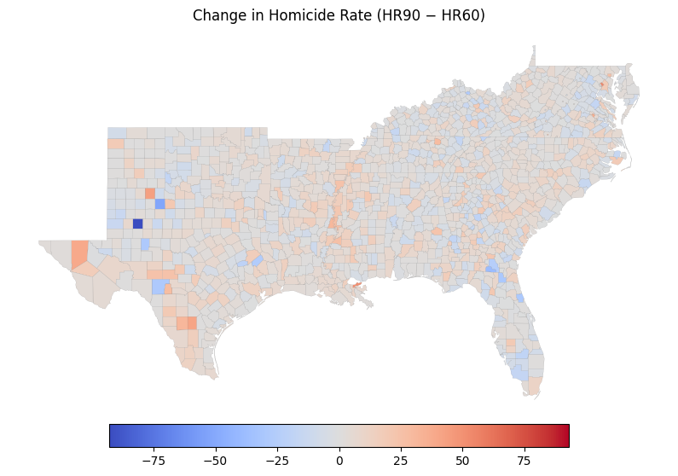
Figure 1: ΔHR map (HR90 – HR60).
Significant reductions in the number of homicides can be observed in some counties in western Texas. Among them, Borden stands out, showing the largest decrease recorded (–92.94). Likewise, most areas have remained stable or have experienced a slight increase in homicide rates. Finally, there are a few hotspots where the rate has risen since 1960.
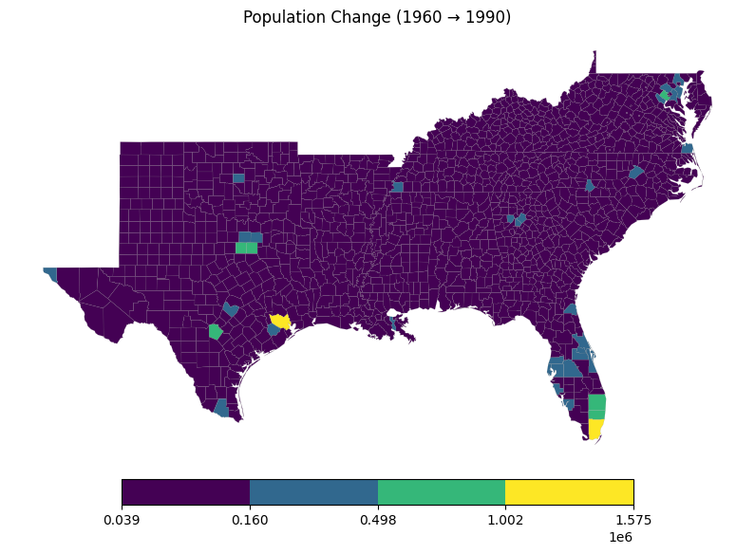

Figure 2: Population change 1960–1990.
Thanks to the classification method employed (Jenks Natural Breaks), it is possible to distinguish very small or declining counties, cities such as Miami or Houston that have grown explosively (in yellow), and middle-class suburbs. In this way, we can identify distinct regions based on population values that originally had an extremely skewed distribution.
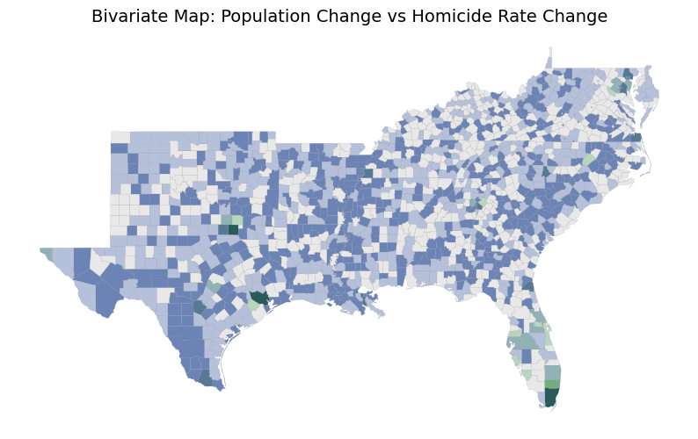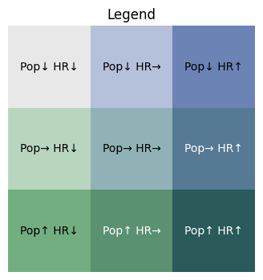
Figure 3: Bivariate Map to visualize the relationship between 1) and 3).
With this final visualization, we can confirm whether population growth has influenced the number of recorded homicides. The clearest cases are Houston (Harris County) and Miami (Dade County), where we can see that massive population growth has negatively affected the number of homicides (increase). Finally, Borden County, mentioned earlier, has been correctly classified, as both its population and its homicide levels have substantially decreased (Pop↓ HR↓).

